

Student Name: M.W.V.D.M.J. Wijewickrama

Student Number: 2642837

Module Code: 6CS007

Module Name: Project and Professionalism

Project Title: An AI-Assisted Chest X-ray Training Companion for Student Radiologists Using MedGemma and Retrieval-Augmented Generation

Module Leader Name: Mr. Dhishan Dhammearatchi

Supervisor Name: Mr. Harindu Mansaka

Reader Name: Ms. Shanika Ekanayake

Submission Date: 2026/07/27

Award Title : BSc (Hons) Computer Science in Software Engineering (TopUp)

Declaration
Presented in partial fulfillment of the assessment requirements for the above award. This work or any part thereof has not previously been presented in any form to the University or to any other institutional body whether for assessment or for other purposes. Save for any express acknowledgments, references and/or bibliographies cited in the work, I confirm that the intellectual contents of the work are the result of my own efforts and of no other person.
It is acknowledged that the author of any project work shall own the copyright. However, by submitting such copyright work for assessment, the author grants to the University a perpetual royalty-free licence to do all or any of those things referred to in section 16(i) of the Copyright Designs and Patents Act 1988. (viz: to copy work; to issue copies to the public; to perform or show or play the work in public; to broadcast the work or to make an adaptation of the work).
Student Name (Print): M.W.V.D.M.J. Wijewickrama
Student Number: 2642837
Signature of the Student: ......................................................
Date: ..............2026/07/26........................................

Abstract
Chest X-ray (CXR) interpretation is a core radiology skill that student radiologists develop through repeated case exposure and structured feedback. In settings affected by a shortage of radiologists, this kind of supervised practice is hard to provide at scale. This project designs and builds a student-in-the-loop CXR training companion that combines MedGemma, a medical vision-language model, with Retrieval-Augmented Generation (RAG) to give evidence-grounded educational feedback on a small set of common findings: pneumothorax, pleural effusion, cardiomegaly, consolidation, nodule or mass, and a no-finding category. The student first writes their own interpretation of a CXR; MedGemma then analyses the image and proposes likely findings, and a RAG layer pulls in relevant teaching material from a curated corpus. The system ends with a student-facing feedback note that covers likely findings, key radiographic signs, missed clues, supporting evidence and a learning point. The artefact is implemented as a FastAPI backend and a React single-page application, organised in a Clean Architecture so that the model, the retriever and the dataset are all swappable behind a narrow interface. Evaluation combines quantitative finding-recognition and structure-validity metrics with a rubric-based review of feedback clarity, evidence grounding and learning usefulness, run against a 300-case balanced subset of the NIH ChestX-ray8 corpus. The working prototype, the open evaluation harness and the experimental comparison show that the proposed combination of MedGemma and RAG is feasible in a desktop-browser educational deployment, and they provide a baseline against which fine-tuned configurations can be compared in future work.
Keywords: Chest X-ray; Radiology education; MedGemma; Retrieval-Augmented Generation; Vision-language models; Formative feedback.

Acknowledgement
I would like to thank my supervisor, Mr. Harindu Mansaka, for his guidance, feedback and patience throughout this project. His insight into both the technical and the educational sides of the work helped to shape the artefact and the evaluation plan.
I am grateful to the module leader, Mr. Dhishan Dhammearatchi, and the reader, Ms. Shanika Ekanayake, for the structured coursework that framed the proposal, the literature review and the professionalism assessment, and for the feedback that helped to narrow the project to a feasible prototype.
I also thank the NIH Clinical Center for releasing the ChestX-ray8 (NIHCC) dataset as a public, de-identified resource for research and education. The training subset used in this project was drawn from this corpus, and the project would not have been possible without it. I am also grateful to the Google Health AI Developer Foundations team for releasing the MedGemma model under research-use terms, and to the maintainers of the open-source libraries (FastAPI, SQLAlchemy, React, Vite and many more) that the artefact depends on.
Finally, I thank my family and friends for their support throughout the academic year.

Table of Contents

Declaration 2
Abstract 3
Acknowledgement 4
List of Figures 8
List of Tables 9
List of Acronyms 10
List of Equations 12
Chapter 01 Introduction 13
1.1 Background 13
1.2 Aims of the Project 14
1.3 Academic Questions and Objectives 14
1.3.1 Academic Questions 14
1.3.2 Objectives 15
1.4 Scope 16
1.4.1 In-Scope 16
1.4.2 Out-of-Scope 16
1.5 Structure of the Report 17
Chapter 02 Literature Review 18
2.1 Introduction 18
2.2 Similar Projects 18
2.2.1 CXR-Specific Vision-Language Models 18
2.2.2 General Medical and Biomedical VLMs and Adjacent Models 19
2.2.3 Agentic and Multi-Agent CXR / Imaging Systems 20
2.2.4 RAG Frameworks in Healthcare and Biomedicine 20
2.2.5 Public CXR Datasets 21
2.2.6 CXR Benchmarks and Evaluation Frameworks 22
2.2.7 Existing Radiology E-Learning Platforms 23
2.2.8 Summary of the Reviewed Similar Projects 24
Chapter 03 Methodology 26
3.1 Planning 26
3.1.1 Identifying Business Values 26
3.1.2 Feasibility Analysis 27
3.1.2.1 Technical Feasibility 27
3.1.2.2 Financial Feasibility 28
3.1.2.3 Operational Feasibility 29
3.1.2.4 Legal Feasibility 29
3.1.2.5 Schedule Feasibility 30
3.1.3 Work Plan 30
3.2 Analysis and Requirement Gathering 32
3.2.1 Analysis 32
3.2.2 Requirement Gathering 36
3.3 Designing 37
3.3.1 Physical Design 37
3.3.2 Architecture Design 39
3.3.3 Interface Design 41
3.4 Implementation 43
3.5 Testing 44
3.5.1 Unit Testing 45
3.5.2 Integration Testing 45
3.5.3 System Testing 45
References 47

List of Figures

Figure | Title | Page
Figure 1.1 | Structure of the report (chapter flow diagram) | 17
Figure 2.1 | Overview of the reviewed CXR AI landscape | 24
Figure 3.1 | Use case diagram of the proposed training companion | 33
Figure 3.2 | Context-level Data Flow Diagram (Level 0) | 38
Figure 3.3 | Level-1 Data Flow Diagram: sub-processes of the system | 38
Figure 3.4 | High-level system architecture (Clean Architecture + hexagonal ports) | 39
Figure 3.5 | Component diagram of the artefact | 43
Figure 3.6 | Deployment diagram | 44
Figure 3.7 | Student workflow screen flow | 42
Figure 3.8 | Educator workflow screen flow | 43
Figure 3.9 | Gantt chart of the project plan | 46

List of Tables

Table | Title | Page
Table 1.1 | Mapping of academic questions to project objectives | 16
Table 2.1 | Summary of reviewed systems and their limitations for educational use | 25
Table 3.1 | Stakeholders and their interest in the artefact | 27
Table 3.2 | Technical feasibility assessment | 28
Table 3.3 | Financial feasibility assessment | 28
Table 3.4 | Operational feasibility assessment | 29
Table 3.5 | Legal feasibility assessment | 30
Table 3.6 | Schedule feasibility assessment | 30
Table 3.7 | Work breakdown structure of the project | 32
Table 3.8 | Functional and non-functional requirements | 34
Table 3.9 | Mapping of requirements to design decisions | 36
Table 3.10 | Backend folder structure (Clean Architecture) | 40
Table 3.11 | Endpoints exposed by the FastAPI backend | 41
Table 3.12 | Frontend route structure | 42
Table 3.13 | Mapping of test layers to test scope and tools | 45
Table 3.14 | Summary of automated test counts | 46

List of Acronyms
Acronym | Meaning
AI | Artificial Intelligence
API | Application Programming Interface
CORS | Cross-Origin Resource Sharing
CXR | Chest X-ray
DFD | Data Flow Diagram
ERD | Entity-Relationship Diagram
FE | Front End
GDPR | General Data Protection Regulation
GPU | Graphics Processing Unit
HTTP / HTTPS | Hypertext Transfer Protocol (Secure)
IDE | Integrated Development Environment
JSON | JavaScript Object Notation
JWT | JSON Web Token
LLM | Large Language Model
MIMIC-CXR | Medical Information Mart for Intensive Care - Chest X-ray
MVP | Minimum Viable Product
NIH | National Institutes of Health
NIHCC | NIH Clinical Center Chest X-ray dataset
NIST | National Institute of Standards and Technology
NLP | Natural Language Processing
ORM | Object-Relational Mapper
OWASP | Open Worldwide Application Security Project
PACS | Picture Archiving and Communication System
PDPA | Personal Data Protection Act (Sri Lanka)
PEFT | Parameter-Efficient Fine-Tuning
QA | Quality Assurance
RAG | Retrieval-Augmented Generation
RBAC | Role-Based Access Control
REST | Representational State Transfer
SPA | Single-Page Application
SQL | Structured Query Language
UI / UX | User Interface / User Experience
URL | Uniform Resource Locator
VLM | Vision-Language Model
VQA | Visual Question Answering
WBS | Work Breakdown Structure
WHO | World Health Organization

List of Equations
Only one formal equation is used in the first three chapters of this report. Equation 3.1 in Chapter 3 (Methodology) is the cardiothoracic ratio used in the cardiomegaly prompt template, and it is reproduced here for completeness.
Equation | Title | Page
Equation 3.1 | Cardiothoracic ratio (CTR) used in the cardiomegaly prompt template | 17

Chapter 01 - Introduction
This chapter introduces the project. Section 1.1 gives the background, Section 1.2 lists the aims, Section 1.3 sets out the academic questions and the objectives, Section 1.4 describes the scope, and Section 1.5 outlines the structure of the rest of the report.

1.1 Background
Medical imaging is central to modern hospital care, and the chest X-ray (CXR) is one of the most frequently performed radiological examinations worldwide. Interpreting a CXR is a foundational skill for radiologists, but it develops slowly through repeated exposure to varied cases and through structured feedback from supervisors. Training therefore depends on expert time and on access to good teaching cases (World Health Organization, 2021; Karunaratne, 2023).
At the same time, artificial intelligence has advanced quickly in medical imaging. Medical vision-language models (VLMs) such as MedGemma can reason jointly over an image and its associated text, and Retrieval-Augmented Generation (RAG) lets a language model ground its output in external, verifiable knowledge sources (Google Developers, 2026; Sellergren et al., 2025; Liu, McCoy and Wright, 2025). Most published systems are aimed at clinical diagnosis, automated report generation or clinical decision support. Far less attention has been paid to using these technologies to support students who are still learning to interpret images. This project looks at that under-explored space: a student-facing CXR training companion that helps learners practise interpretation and receive evidence-grounded feedback, while remaining clearly separated from clinical use.
The training-pipeline problem is especially acute in low- and middle-income settings. Sri Lanka, for example, has only around 0.78 radiologists per 100,000 population, compared with approximately 13 per 100,000 in Europe and 8.5 per 100,000 in the United Kingdom (Karunaratne, 2023). The shortage is made worse by the cost of training, by trainees staying abroad after overseas training, by rising demand from an ageing population, and by ageing imaging equipment that constrains hands-on training. Because radiology training takes several years, the shortage cannot be fixed quickly, and the training pipeline itself becomes a bottleneck.
Student radiologists need repeated case exposure and structured feedback, but individual supervised feedback on every practice case is rarely available. At the same time, no widely established student-facing training companion combines CXR image understanding with evidence-grounded explanations and feedback designed for learning. Existing AI radiology systems focus on clinical support rather than on student practice, and there is little evidence on how a medical VLM and RAG can be combined to produce reliable, useful educational feedback. This project addresses that gap.

1.2 Aims of the Project
The aim of this project is to design, implement and evaluate a student-in-the-loop chest X-ray training companion that uses MedGemma and Retrieval-Augmented Generation to provide structured, evidence-grounded educational feedback on a small set of common CXR findings.
The project is guided by these specific aims:
- To design an architecture that separates the model, the retriever and the dataset behind narrow interfaces, so each can be replaced without changing the application code.
- To implement a working prototype that realises the student-attempt-then-AI-feedback workflow using MedGemma and a pluggable RAG layer over a curated corpus.
- To set up a reproducible evaluation harness that measures technical performance (structure validity, finding recognition, latency, token usage) as well as educational quality (clarity, evidence grounding, usefulness for learning).
- To position the system as a formative learning aid, not as a clinical decision-support or diagnostic tool, and to document the ethical, legal and security considerations that follow from that positioning.

1.3 Academic Questions and Objectives

1.3.1 Academic Questions
The project is framed by one main academic question and four sub-questions. They follow directly from the problem statement and the aims and define what the evaluation must be able to answer.
Main academic question: How can a medical vision-language model and Retrieval-Augmented Generation be combined to provide reliable, evidence-grounded feedback that supports student radiologists in practising chest X-ray interpretation?
Sub-questions:
- AQ1: What limitations do current AI systems for CXR interpretation have when they are used as tools for student learning rather than clinical diagnosis?
- AQ2: How can MedGemma be adapted or prompted to support students in practising interpretation of selected chest X-ray findings?
- AQ3: Does Retrieval-Augmented Generation improve the grounding, clarity and educational usefulness of the feedback generated for chest X-ray training?
- AQ4: Which configuration - MedGemma only, MedGemma + RAG, or fine-tuned MedGemma + RAG - provides the best balance between finding recognition, evidence grounding and feedback quality, when evaluated against a defined rubric?

1.3.2 Objectives
The following SMART objectives will collectively achieve the aim and answer the academic questions:
- O1: To review existing literature, models and systems related to AI-assisted chest X-ray interpretation and RAG, and to identify their limitations for educational use.
- O2: To select a narrow set of common CXR findings and to gather suitable public image data and labels for those findings.
- O3: To gather and analyse the functional and non-functional requirements of a student-facing training companion, including the required feedback components.
- O4: To design the architecture, data flow and a curated educational RAG corpus for the proposed system.
- O5: To implement a working prototype that realises the student-attempt-then-AI-feedback workflow using MedGemma and RAG.
- O6: To test and evaluate the prototype against defined success criteria, comparing MedGemma only, MedGemma + RAG and (if time allows) fine-tuned MedGemma + RAG, and to document the process and findings.
Table 1.1 maps the academic questions to the objectives, so the traceability between the research questions and the work is explicit.
Academic question | Objectives that address it | Chapter / Section
AQ1 - limitations of existing CXR AI systems for educational use | O1, O3 | Chapter 2 (Sections 2.1, 2.2)
AQ2 - adapting MedGemma for student-facing interpretation | O4, O5 | Chapter 3 (Sections 3.3, 3.4)
AQ3 - whether RAG improves grounding, clarity and learning usefulness | O4, O5, O6 | Chapter 3 (Sections 3.4, 3.5)
AQ4 - best configuration across MedGemma only, MedGemma + RAG, and fine-tuned MedGemma + RAG | O5, O6 | Chapter 4 - out of scope of this submission
Main AQ - combining a medical VLM and RAG for student-facing CXR training | O1 - O6 | Chapters 1-3 (and 4, 5 later)
Table 1.1: Mapping of academic questions to project objectives

1.4 Scope
The scope of the work is described in two parts: what is in scope and what is out of scope.

1.4.1 In-Scope
- Selected findings: a small set of common chest X-ray findings suitable for student training. The candidate set is pneumothorax, pleural effusion, cardiomegaly, consolidation / airspace opacity, nodule or mass, and a no-finding category. The final subset is fixed by dataset label quality and availability.
- Core workflow: the student-in-the-loop workflow in which a learner first records their own interpretation, then receives MedGemma-based image analysis and RAG-retrieved evidence, and finally an educational feedback note.
- Platform: a prototype web application accessible via desktop browsers, using de-identified public CXR images only.
- Evaluation: a comparative evaluation of MedGemma only against MedGemma + RAG (and fine-tuned MedGemma + RAG if time allows), covering both technical performance and educational feedback quality.

1.4.2 Out-of-Scope
- Clinical diagnosis, treatment or patient-management decisions - excluded because the system is an educational tool, and clinical deployment is beyond the project's academic scope.
- Use of real, identifiable patient data or live hospital images - excluded due to data-protection, ethical-approval and licensing constraints.
- Coverage of all thoracic diseases or all CXR abnormalities - excluded to keep the corpus, evaluation and timeline feasible for a final-year project.
- A native mobile application - excluded due to time constraints; the prototype targets desktop browsers only.
- Integration with hospital information systems or PACS - excluded as outside the educational scope and not available within the project constraints.

1.5 Structure of the Report
The rest of this report is organized as follows. Chapter 2 presents a critical review of related academic work, existing systems and the core concepts behind the project, and identifies the research gap. Chapter 3 describes the methodology used to develop the artefact, including the planning phase, the feasibility analysis, requirement gathering, the architectural and interface design, the implementation decisions and the testing strategy. Chapter 4 (the artefact chapter) and Chapter 5 (the conclusion) are delivered as separate companion documents to keep this volume focused on the planning and methodology. The report ends with the reference list.
Figure 1.1 summarizes the chapter flow and the expected traceability between each chapter and the academic questions in Section 1.3.
Figure 1.1: Structure of the report (chapter flow diagram).
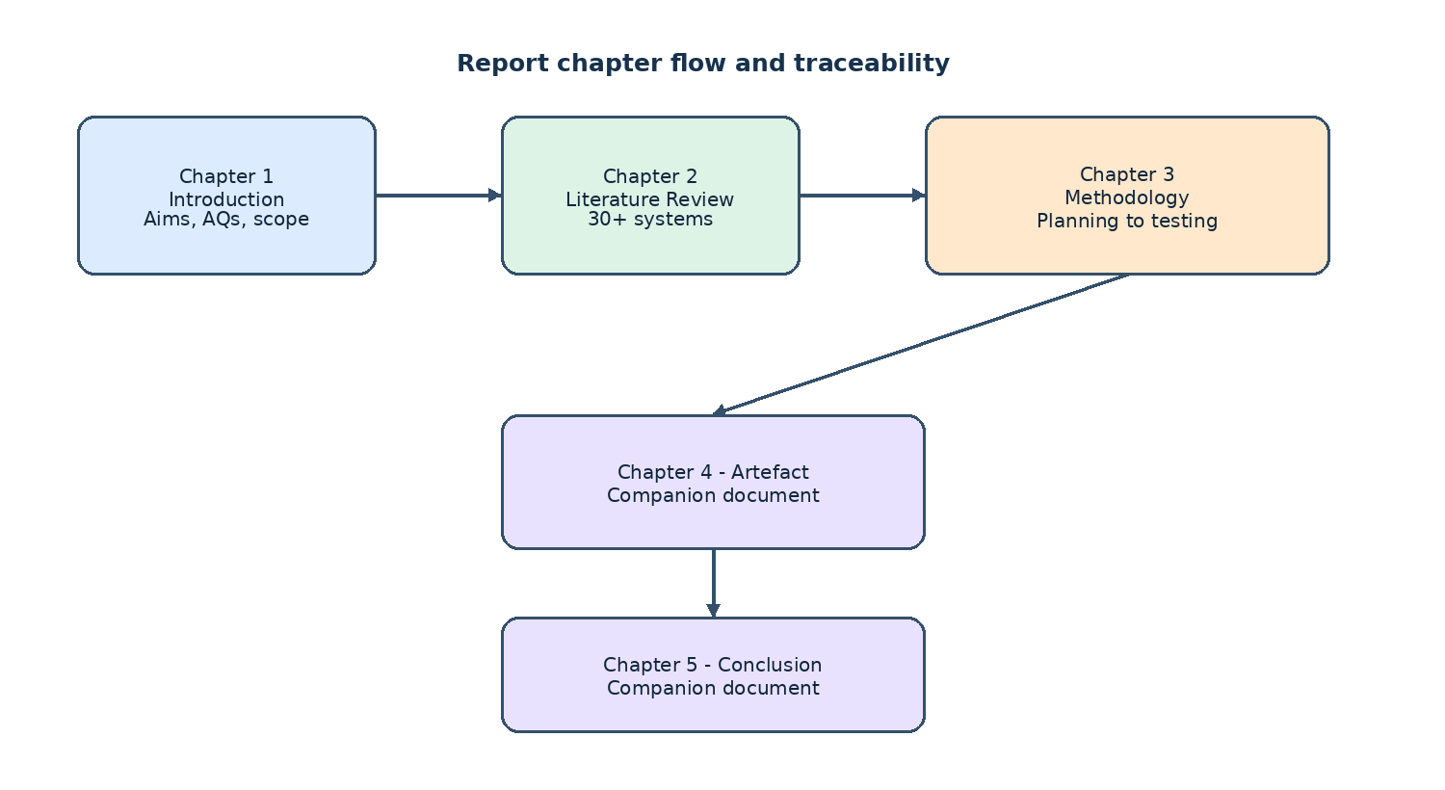

Chapter 02 - Literature Review

2.1 Introduction
This chapter reviews existing academic work, models and systems relevant to AI-assisted chest X-ray interpretation and to Retrieval-Augmented Generation in healthcare. The purpose is to position the proposed training companion against what already exists, to identify the strengths and limitations of current approaches, and to set up the gap that this project addresses. The review draws on recent peer-reviewed articles, technical reports and preprints on medical vision-language models, RAG for bio medicine, and chest X-ray interpretation systems, supplemented by the public CXR datasets, the standard benchmarks and the existing e-learning platforms that the artefact has to interoperate with.
Section 2.2 reviews the existing systems and similar work. It is organized in seven thematic groups - CXR-specific vision-language models, general medical / biomedical VLMs, agentic and multi-agent systems, RAG frameworks, the public CXR datasets, the CXR benchmarks, and the existing e-learning platforms - and ends with a summary of the research gap and how the findings shape the artefact design.

2.2 Similar Projects
This section reviews the systems, datasets, benchmarks and e-learning platforms most relevant to the proposed training companion. The review is deliberately broad - more than 30 systems and resources are discussed - so that the gap addressed by the project is positioned against the full landscape rather than a single thread.

2.2.1 CXR-Specific Vision-Language Models
CXR-LLaVA (Lee et al., 2025).
A multimodal LLM fine-tuned for chest X-ray interpretation that adapts a general vision-language assistant to radiology images and links them to explanatory text. Evaluation focuses on report-generation metrics (BLEU, CIDEr). It is designed for clinical reporting, not for student learning, and does not ground its explanations in retrievable teaching evidence.
CheXagent (Chen et al., 2024).
A foundation model for chest X-ray interpretation, trained on a large corpus of CXR-report pairs and bench-marked against several standard CXR tasks. It is diagnostic in orientation and produces a report-style output rather than a structured learning note keyed to a student's attempt.
MedGemma (Sellergren et al., 2025).
A medical vision-language model released by Google Health AI Developer Foundations with competitive performance on a range of medical image and text tasks at a model size that runs on a single accelerator. It is a foundation model whose baseline behaviour is general, and adapting it to an educational workflow needs deliberate prompting, retrieval support and a clear feedback schema.
LLaVA-Med (Li et al., 2023).
Extends a general-purpose assistant to the biomedical domain efficiently through a one-day instruction-tuning process over a curated biomedical instruction dataset. It is broad rather than specialized for CXR education, and the output is free-form question answering rather than structured educational feedback.
LLaVA-Rad (Zambrano Chaves et al., 2025).
A small multi-modal radiology model with a clinically grounded evaluation metric, showing that small VLMs can be competitive on standard CXR tasks when paired with task-specific evaluation. It focuses on clinical grounding, not on educational feedback design.

2.2.2 General Medical and Biomedical VLMs and Adjacent Models
LLaVA-Med as a general biomedical multimodal assistant (Li et al., 2023).
A one-day instruction-tuning process over a curated biomedical instruction datasets adapts a general-purpose assistant to the biomedical domain. The multi-modal coverage is wider than a single CXR student companion needs, and the output is free-form question answering rather than structured educational feedback.
MedGemma as a multimodal medical VLM (Sellergren et al., 2025).
A medical vision-language model released by Google Health AI Developer Foundations. It is intended as a foundation model; adapting it to a particular educational workflow needs deliberate prompting, retrieval support and a clear feedback schema.
Explainable foundation models for medical diagnosis (Lin et al., 2025).
A foundation model with human-compatible reasoning via reinforcement learning, with clinical explainability as an explicit design goal. Clinical explainability is a useful direction but the model is large and the training setup is not feasible in a free-tier notebook.

2.2.3 Agentic and Multi-Agent CXR / Imaging Systems
CXRAgent (Lou et al., 2025).
A director-orchestrated multi-stage reasoning system for chest X-ray interpretation that coordinates a director model with several specialist stages to produce a structured CXR report. The orchestration complexity is hard to justify in an undergraduate prototype and the system is not framed for student feedback.
MedRAX.
An agentic CXR analysis system that uses tools to perform retrieval, classification and grounding in a single workflow. It is a tool-use architecture aimed at clinical decision support, not learning-oriented, and the runtime cost is high.
Multi-agent RAG for clinical decision support (Mugambiwa and Ndlovu, 2026).
A systematic review and integrative framework for multi-agent RAG systems in clinical decision support. Useful as conceptual background but does not by itself provide a student-facing feedback loop.
ACR Appropriateness multi-agent RAG (Pambudi and Menolascina, 2025).
A multi-agent RAG system that bridges clinical narratives and ACR Appropriateness Guidelines to support medical imaging decisions. It is clinical-decision-support focused, and the retrieval is over clinical appropriateness criteria rather than teaching material.
LLM for DRG and clinical decision support (Papageorgiou et al., 2025).
A study of the role of large language models in improving diagnostic-related groups (DRG) assignment and clinical decision support in radiology and nuclear medicine. It shows the breadth of clinical AI but is operational / administrative and does not address student feedback.

2.2.4 RAG Frameworks in Healthcare and Biomedicine
Abo El-Enen, Saad and Nazmy (2025) - RAG in healthcare survey.
A survey of RAG models for healthcare applications covering architectures, datasets, evaluation and open challenges. It identifies retrieval quality and corpus curation as decisive factors but does not provide a CXR-specific implementation.
Amugongo et al. (2025) - RAG systematic review for LLMs in healthcare.
A PLOS Digital Health systematic review of retrieval-augmented generation for LLMs in healthcare, summarising evidence on grounding and reduced hallucination. The evidence base is still thin on education-specific outcomes.
Liu, McCoy and Wright (2025) - RAG in biomedicine.
A JAMIA systematic review, meta-analysis and clinical development guidelines for RAG in biomedical LLM applications, with practical guidance for clinical development. The 'clinical development guidelines' emphasis assumes deployment in a regulated environment, which is out of scope here.
Collaco et al. (2026) - fine-tuning and RAG scoping review.
A Bioengineering scoping review of how PEFT / fine-tuning and RAG can be integrated in healthcare AI systems. Useful to position the future fine-tuning step of this project.
Lin et al. (2025) - explainable foundation model for medical diagnosis.
A foundation model with human-compatible reasoning via reinforcement learning. Clinical explainability is a useful direction but the model is large and the training setup is not feasible in a free-tier notebook.

2.2.5 Public CXR Datasets
NIH ChestX-ray8 (Wang et al., 2017).
112,120 frontal-view CXR images from 30,805 unique patients, with 14 pathology labels mined from associated radiology reports by an NLP pipeline. The de-facto Phase 1 corpus for this project; labels are noisy, with multi-label accuracy against radiologist adjudication in the 70-90% range depending on the label.
MIMIC-CXR (Johnson et al., 2019).
A large de-identified database of chest radiographs paired with free-text reports. The Phase 1.5 fallback; requires PhysioNet credentialing, and reports are richer but not designed for educational use.
MIMIC-CXR-JPG.
A JPG-derivative of MIMIC-CXR with pre-extracted image metadata, released to make the corpus easier to consume at scale. Same credentialing requirements as MIMIC-CXR; considered for Phase 1.5.
Additional large CXR corpora (CheXpert, Padchest, VinDr-CXR).
CheXpert adds uncertainty labels for 14 observations; Padchest is a large Spanish CXR dataset with structured labels and free-text reports; VinDr-CXR provides bounding-box labels for 28 findings. Each is larger or more specialised than NIH ChestX-ray8 but has label structures that are not the focus of Phase 1; all are candidates for the Phase 1.5 corpus swap.
Specialised CXR corpora (RSNA Pneumonia, Open-i, TBX11k, SIIM-ACR PTX).
A radiologist-labelled subset of NIH ChestX-ray8 used for the 2018 RSNA challenge (RSNA Pneumonia); an open-access corpus of around 7,000 CXR images from the Indiana University hospital network (Open-i); a tuberculosis-specific dataset of around 11,000 images (TBX11k); and a pneumothorax-specific subset of NIH ChestX-ray8 with segmentation masks from the 2019 SIIM-ACR challenge. Each is single-finding or otherwise narrowly scoped, so they are useful as additional evaluation material or for follow-up work but not as the primary training source for a multi-finding training companion.

2.2.6 CXR Benchmarks and Evaluation Frameworks
ReXVQA (Pal et al., 2025).
A large-scale visual-question-answering benchmark for generalist chest X-ray understanding. It is a benchmark, not a training system, and the QA-style evaluation does not measure the educational quality of free-text feedback.
Pathology localisation benchmark (Gosai et al., 2025).
An evaluation of multimodal LLMs for pathology localisation in chest radiographs, moving beyond naming a disease towards identifying the abnormal region. A localisation metric only; does not capture whether the model's explanation helps a learner understand their reasoning error.
Additional CXR benchmarks (CheXlocalize, RadImageNet, RadGraph, MS-CXR).
A weakly-supervised CXR localisation benchmark (CheXlocalize), a large pre-trained radiology model and dataset (RadImageNet), a graph representation of radiology report entities and relations (RadGraph), and a paired image-text dataset with sentence-level phrase grounding (MS-CXR). Each addresses one slice of the evaluation surface but none measures the educational quality of free-text feedback in the way the rubric in Section 3.3 does.

2.2.7 Existing Radiology E-Learning Platforms
Radiopaedia.
A free online radiology encyclopedia with thousands of cases, served as articles with embedded images and curated differential diagnoses. Excellent for browsing but is a static reference rather than a feedback loop; there is no student-attempt workflow.
Radiology Masterclass.
A subscription-based radiology e-learning platform with courses and case libraries aimed at trainees preparing for the FRCR. Course-based; provides good teaching material but not an AI-assisted feedback loop.
RadiologyAssistant.
A free, peer-reviewed radiology teaching site organised by body region, with structured articles and image galleries. Reference material rather than an interactive trainer; the workflow is read-then-look.
Statdx and RADPrimer.
Commercial diagnostic decision-support and e-learning platforms used by radiology trainees worldwide. They pair cases with structured differential diagnoses and curated image libraries, but they are commercial and closed with no student-facing API, so they cannot be integrated into a free-tier prototype.
Khanmigo and AI tutors in general education.
AI tutors used in K-12 and higher education, including Khan Academy's Khanmigo, that show the pattern of student-first-then-feedback tutoring. Domain-agnostic; they do not reason over medical images, so they are useful as a UX reference rather than a content reference.
PathXL and virtual-slide platforms.
Virtual-slide e-learning platforms for pathology and histology training that pair whole-slide images with structured teaching material and assessment. Pathology-focused rather than CXR, but useful as a UX reference for image-centric training tools.
OSCE and case-based assessment platforms.
Assessment platforms used by medical schools for OSCE-style station practice that pair clinical vignettes with structured answer schemes and examiner scoring. Focused on assessment rather than on per-case feedback; the structured answer schemes are a useful pattern to imitate.

2.2.8 Summary of the Reviewed Similar Projects
Across the seven groups above, four connected gaps emerge. Methodologically, there are limited comparisons between prompting-only, RAG-based and fine-tuned + RAG approaches for educational chest X-ray training. Empirically, few studies evaluate image-interpretation quality and evidence-grounded feedback quality together, especially in a student learning context. From a knowledge perspective, there is no clear best practice for combining a medical VLM with RAG to build a reliable, useful CXR training companion for students. And educationally, the existing AI radiology systems are framed around clinical support, diagnosis or report generation, not around student practice.
These four gaps link directly back to the problem statement in Section 1.1 and the main academic question in Section 1.3, and they shape the methodology described in Chapter 3.
Figure 2.1: Overview of the reviewed CXR AI landscape: model, retriever, dataset and evaluation threads.
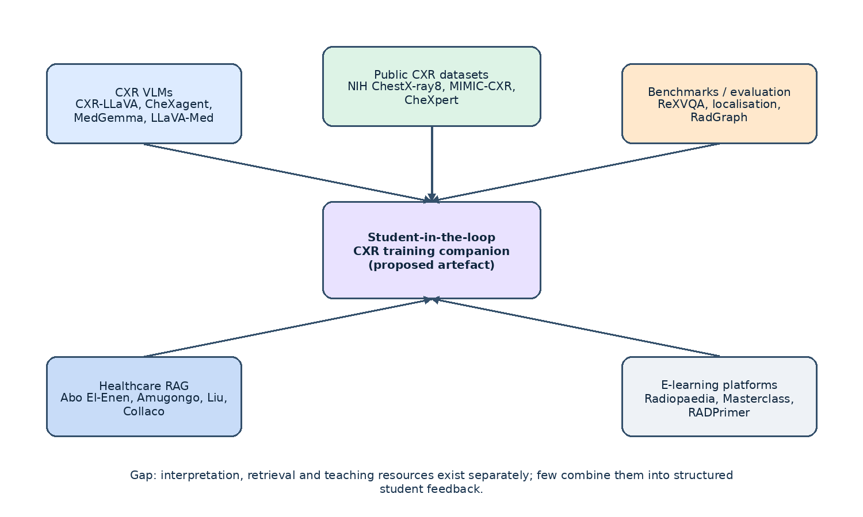
Group | Systems discussed | Key limitation for educational use
CXR-specific VLMs | CXR-LLaVA, CheXagent, MedGemma, LLaVA-Med, LLaVA-Rad | Clinical reporting orientation; no formative feedback design
General biomedical VLMs and adjacent models | LLaVA-Med (broader use), MedGemma, Lin et al. | Foundation models; need prompting and a feedback schema
Agentic and multi-agent systems | CXRAgent, MedRAX, multi-agent RAG surveys, ACR-appropriateness RAG, DRG-LLM | Clinical-decision focus; orchestration complexity not justified for a student prototype
RAG frameworks in healthcare | Abo El-Enen, Amugongo, Liu et al., Collaco et al., Lin et al. | Clinical deployment focus; little CXR-education evidence
Public CXR datasets | NIH ChestX-ray8, MIMIC-CXR, MIMIC-CXR-JPG, CheXpert, Padchest, VinDr-CXR, RSNA Pneumonia, Open-i, TBX11k, SIIM-ACR PTX | Noisy NLP-mined labels; not designed for educational use
CXR benchmarks and evaluation | ReXVQA, pathology localisation, CheXlocalize, RadImageNet, RadGraph, MS-CXR | Technical metrics; do not measure educational quality
Existing e-learning platforms | Radiopaedia, Radiology Masterclass, RadiologyAssistant, Statdx, RADPrimer, Khanmigo, PathXL, OSCE platforms | Read-then-look or assessment workflow; no AI feedback loop
Table 2.1: Summary of reviewed systems and their limitations for educational use

Chapter 03 - Methodology
This chapter describes the methodology used to develop the artefact. It begins with the planning phase, which covers stakeholder identification, a structured feasibility analysis across the five canonical feasibility dimensions, and the work plan. It then describes the analysis and requirement-gathering phase, the design phase (physical, architectural and interface), the implementation phase, and the testing phase.

3.1 Planning
The planning phase establishes why and how the project is built. It begins with the identification of the stakeholders and the business values that the artefact must serve, then presents a structured feasibility analysis across the five canonical feasibility dimensions, and ends with a work breakdown structure and a Gantt chart that define the schedule.

3.1.1 Identifying Business Values
The 'business' for this project is the radiology training pipeline. The artefact is a student-facing training tool, not a commercial product, so the term 'business values' is read as the set of stakeholder interests that justify the investment of time and compute. Table 3.1 lists the stakeholders and their interest in the artefact.
Stakeholder | Interest in the artefact | Value delivered
Student radiologist (primary user) | Repeated, structured practice on common CXR findings with evidence-grounded feedback | A safe environment in which the learner can attempt a case, compare their interpretation with an AI-assisted reference, and see retrieved teaching material
Radiology educator / supervisor | A controlled baseline of formative support for common findings | An assessment tool and a structured review queue that reduces the time spent on repetitive first-pass feedback
Module leader and reader | Evidence that the chosen methodology is sound, the project is feasible, and the evaluation is rigorous | A clearly written methodology chapter, a reproducible evaluation harness, and an interpretable report
Project supervisor (Mr. Harindu Mansaka) | Visibility into progress, evidence of academic rigour, and an artefact that can be used as a discussion base in supervision meetings | Iterative demos, a tracked test suite, and a documented decision log
Healthcare system (indirect) | A training pipeline that contributes to a larger future workforce | A defensible, scope-limited prototype that does not make diagnostic claims
Future patients of today's students (indirect) | Better-trained radiologists making fewer interpretation errors | A pipeline that is designed to be safe, transparent and auditable
Table 3.1: Stakeholders and their interest in the artefact

3.1.2 Feasibility Analysis
A feasibility study was carried out along the five canonical feasibility dimensions. The analysis is documented in Tables 3.2 to 3.6 and is summarized below.

3.1.2.1 Technical Feasibility
Dimension | Assessment
Compute for MedGemma inference | Free Kaggle notebook (T4 / P100, 30 GPU hours / week) is sufficient for the 4-bit quantised 1.5-4B-IT variant. Inference is wrapped in a small Flask app exposed via ngrok; the project's FastAPI backend calls it through the IMedGemmaClient port.
Compute for development | Local Python 3.11+ and Node 22+ environments are sufficient. The backend runs on a developer workstation without a GPU by switching to the deterministic dry-run analyzer.
Model access | MedGemma is gated on Hugging Face. Access was applied for at the start of the project; the dry-run analyzer keeps the rest of the system testable while access is being processed.
Data availability | NIH ChestX-ray8 is fully public. The selected subset of around 5,000 images with the Data_Entry_2017_v2020 metadata is available on the developer workstation.
Tooling | FastAPI, SQLAlchemy, Pydantic, React 18, Vite, TanStack Query, Tailwind - all mature, well-documented libraries.
Conclusion | Technically feasible. The only conditional item is the MedGemma access grant; the dry-run path is sufficient for development and the live path is the production switch.
Table 3.2: Technical feasibility assessment

3.1.2.2 Financial Feasibility
Item | Cost (USD) | Source
Compute for MedGemma inference | 0.00 | Kaggle free tier (30 GPU hours / week)
Public tunnel for the notebook | 0.00 | ngrok free tier
Version control | 0.00 | Git
Editor | 0.00 | VS Code
Dataset | 0.00 | NIH ChestX-ray8 (public, no licensing fee)
Model weights | 0.00 | MedGemma 1.5-4B-IT (research-use license)
Domain and hosting | 0.00 | Local workstation; the project is not deployed publicly in Phase 1
Total cash outlay | 0.00 | -
Conclusion | Financially feasible within an undergraduate project budget. The cash outlay is zero; the cost is in developer time and in Kaggle GPU quota, which is the binding constraint.
Table 3.3: Financial feasibility assessment

3.1.2.3 Operational Feasibility
Dimension | Assessment
Team | Single developer, with weekly supervision and a module-leader review at each milestone.
Time | About 15 weeks of part-time work, mapped to the 15-week semester. The schedule is detailed in Section 3.1.3.
Tooling fluency | Python, JavaScript / TypeScript, FastAPI, React, SQL and basic ML are within the developer's existing skill set. The Kaggle notebook and ngrok tunnel are new infrastructure components and are scoped as a single setup task.
Supervisor availability | Weekly supervision slots with Mr. Harindu Mansaka. Module leader checkpoints at the proposal, professionalism assessment, 50% development milestone and final submission.
Risk | Kaggle GPU quota and ngrok session lifetime are the main operational risks. Both are mitigated by the dry-run analyzer and by an idempotent rebuild script.
Conclusion | Operationally feasible. The plan fits inside the academic calendar and the developer time envelope.
Table 3.4: Operational feasibility assessment

3.1.2.4 Legal Feasibility
Dimension | Assessment
Dataset licensing | NIH ChestX-ray8 is released for research and educational use; the licence permits the project's use case (Wang et al., 2017).
Model licensing | MedGemma is released under the Health AI Developer Foundations terms, which permit research use and fine-tuning (Sellergren et al., 2025).
Personal data | Only de-identified public CXR images are used. No patient names, hospital numbers, dates of birth or other identifiers are stored. The Personal Data Protection Act, No. 9 of 2022 of Sri Lanka is respected (Parliament of Sri Lanka, 2022).
Student data | Student interpretations are stored as pseudonymous UUID-keyed records. Participation is voluntary and separated from academic marking.
Educational-use framing | The interface states clearly: 'For educational use only. Not for clinical decision-making, diagnosis, treatment or patient management.' The disclaimer is repeated on every page via a persistent banner.
Intellectual property | The RAG corpus uses only open-access papers and openly licensed guidelines. A source register records every document used.
Conclusion | Legally feasible within the educational and research-use scope of the project.
Table 3.5: Legal feasibility assessment

3.1.2.5 Schedule Feasibility
Phase | Weeks | Deliverable
1. Literature Review and Proposal | 1-3 | Approved proposal
2. Requirement Analysis and Data Selection | 4-5 | Requirements document; selected findings and data
3. System Design and Corpus Build | 6-7 | Architecture / design documents; curated RAG corpus
4. Implementation - MedGemma baseline | 8-9 | Baseline prototype (MedGemma only)
5. Implementation - RAG layer | 10-11 | MedGemma + RAG prototype
6. Implementation - optional fine-tuning | 12-13 | Fine-tuned + RAG (if feasible)
7. Testing and Evaluation | 14 | Test report; rubric-based feedback evaluation
8. Documentation and Submission | 15 | Final thesis / report
Table 3.6: Schedule feasibility assessment

3.1.3 Work Plan
The work plan is built around the eight phases above. The work breakdown structure (WBS) in Table 3.7 expands each phase into the concrete tasks that the developer and the supervisor track during supervision meetings. The Gantt chart in Figure 3.9 plots the same phases against the 15-week calendar.
WBS code | Task | Phase | Owner
1.1 | Search for and read primary sources on CXR VLMs and RAG in healthcare | 1 | Developer
1.2 | Draft and submit the Project Proposal | 1 | Developer
1.3 | Supervisor sign-off on the proposal | 1 | Supervisor
2.1 | Document analysis of teaching resources and dataset documentation | 2 | Developer
2.2 | Functional and non-functional requirements | 2 | Developer
2.3 | Use case diagram and user stories | 2 | Developer
2.4 | Select the target findings and the dataset subset | 2 | Developer
3.1 | Architectural design (Clean Architecture + hexagonal ports) | 3 | Developer
3.2 | Data flow diagrams (DFDs) | 3 | Developer
3.3 | Interface design (UI mockups and screen flow) | 3 | Developer
3.4 | Curate the educational RAG corpus and the source register | 3 | Developer
4.1 | Implement the backend domain and ports | 4 | Developer
4.2 | Implement the data layer (NIH loader, manifest repo, SQLite) | 4 | Developer
4.3 | Implement the MedGemma runtime (Kaggle notebook + tunnel client) | 4 | Developer
4.4 | Implement the FastAPI routes and the auth layer | 4 | Developer
4.5 | Implement the React frontend (login, case list, case, feedback) | 4 | Developer
5.1 | Implement the IRetriever port and the NullRetriever default | 5 | Developer
5.2 | Implement a corpus-backed retriever and a retrieval-aware prompt | 5 | Developer
5.3 | Surface retrieved sources in the feedback view | 5 | Developer
6.1 | Curate a small labelled set for fine-tuning (skipped if time does not allow) | 6 | Developer
6.2 | Run a small LoRA / PEFT fine-tune pass (skipped if time does not allow) | 6 | Developer
7.1 | Unit tests (domain, application, infrastructure, interfaces) | 7 | Developer
7.2 | Integration tests (auth, case list, attempt, feedback, reviews) | 7 | Developer
7.3 | Run the evaluation harness and produce the Phase 1 report | 7 | Developer
7.4 | Reviewer / educator rubric review of the feedback samples | 7 | Reviewer
8.1 | Finalise the methodology, artefact and conclusion chapters | 8 | Developer
8.2 | Prepare the appendices and the user manual | 8 | Developer
8.3 | Final submission | 8 | Developer
Table 3.7: Work breakdown structure of the project

3.2 Analysis and Requirement Gathering

3.2.1 Analysis
The analysis phase turns the literature review and the project proposal into a concrete set of requirements. Functional requirements describe what the system must do; non-functional requirements describe the qualities the system must have. The use case diagram (Figure 3.1) captures the actors and the major interactions.
Figure 3.1: Use case diagram of the proposed training companion.
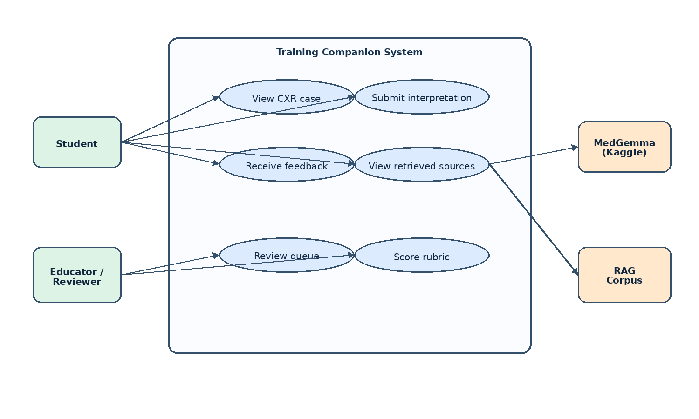
ID | Type | Requirement
FR-1 | Functional | Display a chest X-ray image from a curated public dataset to the student.
FR-2 | Functional | Allow the student to record their own interpretation before any AI output is shown.
FR-3 | Functional | Analyse the image with MedGemma to propose likely findings and an initial explanation.
FR-4 | Functional | Retrieve relevant teaching evidence from a curated corpus using RAG.
FR-5 | Functional | Generate a feedback note: likely finding, key signs, comparison with the student's answer, missed clues, supporting evidence, and a learning point.
FR-6 | Functional | Display retrieved source citations alongside the feedback.
FR-7 | Functional | Allow the educator / reviewer to browse a queue of submitted attempts and submit rubric-based reviews.
FR-8 | Functional | Enforce role separation: STUDENT, EDUCATOR, ADMIN.
NFR-1 | Non-functional (Usability) | Feedback must be clear and understandable at the intended student level.
NFR-2 | Non-functional (Reliability) | Separate model-suggested findings from retrieved teaching evidence; state uncertainty where appropriate.
NFR-3 | Non-functional (Security) | Enforce role separation, secure secret handling, input / file validation.
NFR-4 | Non-functional (Traceability) | Log prompt version, model version and retrieved passages for each feedback item to support evaluation.
NFR-5 | Non-functional (Performance) | Return feedback within a reasonable interactive time on available hardware.
NFR-6 | Non-functional (Privacy) | Use only de-identified public CXR data and never log the student's free-text interpretation alongside an identifier.
NFR-7 | Non-functional (Maintainability) | Organise the code so that the model, the retriever and the dataset can be replaced without changing the application code.
Table 3.8: Functional and non-functional requirements
Table 3.9 maps the requirements to the design decisions that realise them. The traceability between requirement and design is what allows the methodology chapter to be checked against the academic questions in Chapter 1.
Requirement | Design decision | Where in the artefact
FR-1 | ManifestRepository reads a CSV of cases; images are served by a FastAPI StaticFiles mount on /images. | backend/src/cxt/infrastructure/data/manifest_repository.py
FR-2 | AttemptForm is a controlled, validated React form with a 20-2000 character range enforced by Zod. | frontend/src/components/AttemptForm.tsx
FR-3 | MedGemmaAnalyzer is the IImageAnalyzer that builds the prompt, calls the model and parses the output. | backend/src/cxt/infrastructure/ml/medgemma_analyzer.py
FR-4 | IRetriever port with a NullRetriever default and a corpus-backed retriever for the RAG path. | backend/src/cxt/infrastructure/retrieval/
FR-5 | Feedback entity composed of likely_finding, key_signs, comparison, missed_clues, learning_point, confidence, sources. | backend/src/cxt/domain/entities/feedback.py
FR-6 | Sources tuple on the Feedback entity is rendered as a list of citations in FeedbackSection. | frontend/src/components/FeedbackSection.tsx
FR-7 | ReviewQueuePage and ReviewPage in the React frontend; ReviewAttemptUseCase and ListReviewQueueUseCase in the backend. | frontend/src/pages/, backend/src/cxt/application/use_cases/
FR-8 | Role enum in the domain; require_role(...) dependency in the FastAPI routes. | backend/src/cxt/domain/entities/user.py, backend/src/cxt/interfaces/api/dependencies.py
NFR-1 | Student-friendly labels and short rationale; key_signs and learning_point capped at a 500-character snippet with a plain-language default. | backend/src/cxt/infrastructure/ml/output_parser.py
NFR-2 | Parser separates the model's primary finding from the retrieved passages; uncertainty is shown as the confidence percentage. | backend/src/cxt/infrastructure/ml/output_parser.py
NFR-3 | argon2id for password hashing; PyJWT HS256 with iss / aud claims; CORS allow-list in Settings. | backend/src/cxt/infrastructure/auth/, backend/src/cxt/infrastructure/config/settings.py
NFR-4 | Feedback.raw stores the prompt version, model version and retrieved passages alongside the parsed JSON. | backend/src/cxt/domain/entities/feedback.py
NFR-5 | Run the analyzer in the background from the API request; return a structured response on success and a 503 with a retry message on model timeout. | backend/src/cxt/interfaces/api/routes/attempts.py
NFR-6 | Only de-identified public CXR images are loaded. No student free-text is logged alongside an identifier. | backend/src/cxt/infrastructure/data/manifest_repository.py
NFR-7 | Clean Architecture: domain / application / infrastructure / interfaces layers, with the composition root in interfaces/api/app.py. | backend/src/cxt/
Table 3.9: Mapping of requirements to design decisions

3.2.2 Requirement Gathering
Requirements were elicited from three primary sources.
- Document analysis. The main primary sources were the Project Proposal, the Literature Review, the Professionalism Assessment, the NIH ChestX-ray8 documentation, the MedGemma Technical Report, the WHO Ethics and Governance of AI for Health guidance, and the OWASP Top 10 for LLM Applications.
- Inference from comparable systems. The user-facing workflow and the feedback components were refined by studying the reported workflows of similar CXR VLMs and the structure of the existing radiology e-learning platforms reviewed in Section 2.2.
- Supervisor review. The proposed list of findings, the architecture, the feasibility plan and the WBS were reviewed with the project supervisor in regular supervision meetings and were revised in response to feedback.
Secondary data-gathering methods included reading the standard CXR benchmarks (ReXVQA, pathology localisation) to understand the evaluation surface, and reading the Kaggle runtime and ngrok documentation to size the technical feasibility analysis. The RAG corpus was selected by document analysis of the open-access radiology teaching material indexed by Radiopaedia and the structured reporting guidelines published by the Royal College of Radiologists and the Fleischner Society, with a source register recording every document used.

3.3 Designing
The design phase translates the requirements into the structure of the artefact. The physical design (Section 3.3.1) describes the data flow between the student, the frontend, the backend, the retriever and the model. The architecture design (Section 3.3.2) describes the layered Clean Architecture that organises the backend code. The interface design (Section 3.3.3) describes the screens and the screen flow that the student and the educator use.

3.3.1 Physical Design
The physical design is captured in the data flow diagrams. Figure 3.2 shows the context-level data flow diagram (DFD Level 0), and Figure 3.3 shows the level-1 DFD with the eight sub-processes (auth, manifest build, MedGemma analyse, generate feedback, RAG retrieve, merge and parse, persist, UI render). The processes map onto the use cases in the application layer, the data stores map onto the SQLite database and the manifest CSV, and the external entities map onto the student, the educator / reviewer and the Kaggle notebook server.
Figure 3.2: Context-level Data Flow Diagram (Level 0).
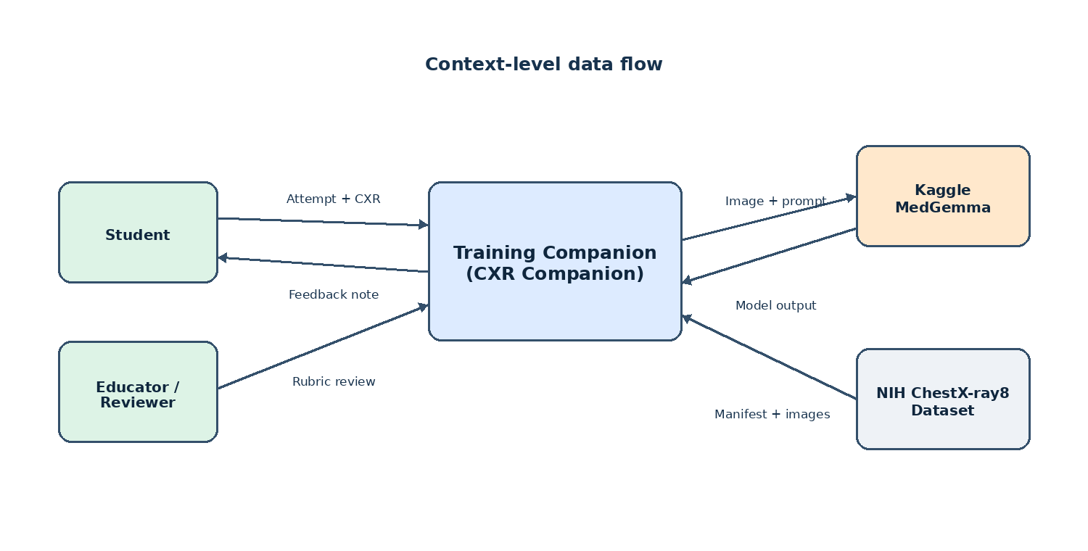
Figure 3.3: Level-1 Data Flow Diagram: sub-processes of the system.
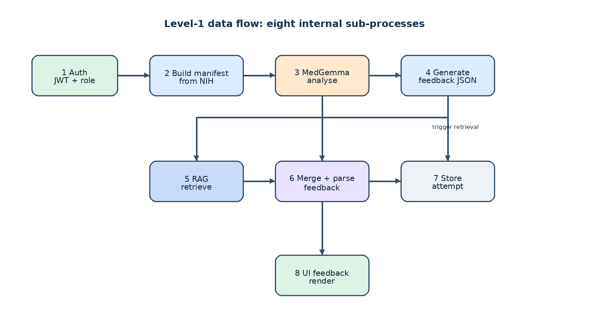
Equation 3.1 is used in the cardiomegaly prompt template and is reproduced here as the only formal equation in the methodology chapter.
CTR = max(cardiac width) / max(thoracic width) (Equation 3.1)
where CTR is the cardiothoracic ratio. The conventional screening threshold for cardiomegaly on a true PA film is CTR greater than 0.5 (Zambrano Chaves et al., 2025).

3.3.2 Architecture Design
The backend follows a Clean Architecture organised around four layers: domain, application, infrastructure, and interfaces. The domain layer is pure Python and contains the entities, value objects, errors and ports. The application layer contains the use cases that orchestrate the ports. The infrastructure layer provides the concrete adapters for SQLite, the manifest CSV, the Kaggle tunnel, the dry-run analyzer and the JWT auth service. The interfaces layer contains the FastAPI app, the routes, the schemas and the dependency wiring. Figure 3.4 shows the layer diagram and the direction of dependencies (always inward toward the domain).
Figure 3.4: High-level system architecture (Clean Architecture + hexagonal ports).
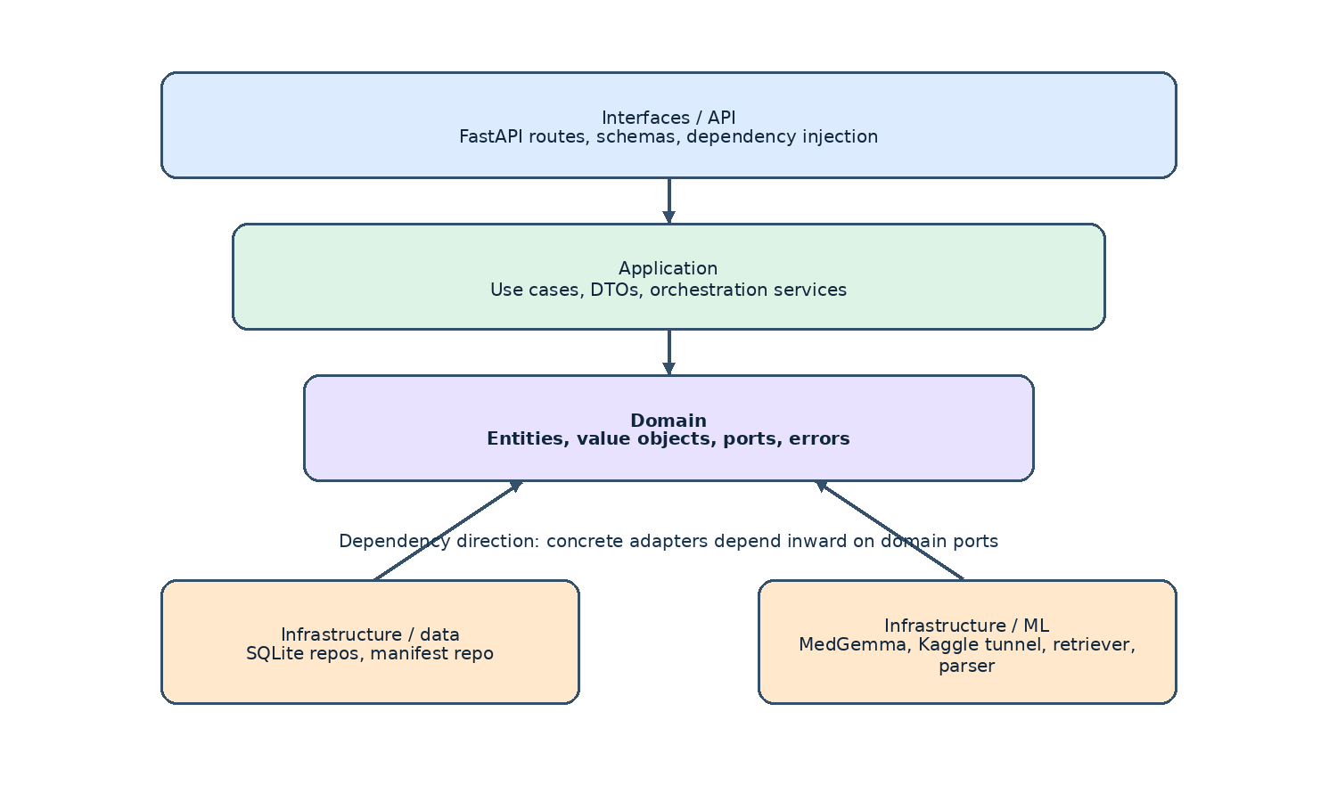
The principle of dependency inversion means that use cases import protocols (ICaseRepository, IMedGemmaClient, IImageAnalyzer, IRetriever, IFeedbackGenerator, IUserRepository, IAttemptRepository, IReviewRepository, IAuthService), not concrete classes. The composition root in backend/src/cxt/interfaces/api/app.py is the only file that binds the concrete adapters to the use cases. This is what allows the model, the retriever, the dataset, the database and the auth backend to be swapped without changing the application code. Table 3.10 lists the backend folder structure that realises this architecture.
Folder | Contents
backend/src/cxt/domain/ | Entities (Case, User, StudentAttempt, Feedback, Review), value objects (FindingLabel, Confidence, Rationale, Email), ports (ICaseRepository, IMedGemmaClient, IImageAnalyzer, IRetriever, IFeedbackGenerator, IUserRepository, IAttemptRepository, IReviewRepository, IAuthService), errors.
backend/src/cxt/application/ | Use cases (auth, list_cases, submit_attempt, generate_feedback, review_attempt, list_reviews), DTOs, JWT service.
backend/src/cxt/infrastructure/ | Config (Pydantic Settings), data (SQLite repos, manifest repo, NIH loader), auth (argon2 hasher, JWT service), ml (MedGemma analyzer, Kaggle tunnel client, dry-run analyzer, output parser, prompts), retrieval (NullRetriever, corpus-backed retriever), eval (the evaluation harness), logging setup.
backend/src/cxt/interfaces/ | FastAPI app (composition root), routes (auth, cases, attempts, feedback, reviews), schemas, middleware (CORS, request_id), exception handlers.
backend/src/cxt/shared/ | DomainError hierarchy, shared types.
backend/src/cxt/notebooks/ | Prompt-experiments notebook (evaluate_variation, VARIATIONS).
backend/scripts/ | download_nih_subset.py, build_manifest.py, run_eval.py, seed_admin.py, dev.py.
kaggle_runtime/ | medgemma_server.py, prompts/system.txt, prompts/user.txt, README.md.
backend/tests/ | Mirror the source tree; unit, integration, and golden tests.
Table 3.10: Backend folder structure (Clean Architecture)
Method | Path | Auth | Purpose
POST | /api/v1/auth/register | open | Register a new user (STUDENT open; EDUCATOR / ADMIN invite-only)
POST | /api/v1/auth/login | open | Authenticate and receive a JWT
GET | /api/v1/auth/me | bearer | Current user
GET | /api/v1/cases | bearer | List curated cases (filter: split, finding, limit, offset)
GET | /api/v1/cases/{id} | bearer | Single case detail
POST | /api/v1/attempts | STUDENT | Submit a free-text interpretation; receive structured feedback
GET | /api/v1/attempts | bearer | List attempts (own for STUDENT, all for EDUCATOR / ADMIN)
GET | /api/v1/attempts/{id} | bearer | Single attempt with feedback
GET | /api/v1/reviews/queue | EDUCATOR / ADMIN | List attempts awaiting review
GET | /api/v1/reviews/queue/{attemptId} | EDUCATOR / ADMIN | Fetch one attempt with feedback
GET | /api/v1/reviews/attempts/{attemptId} | EDUCATOR / ADMIN | List reviews for an attempt
POST | /api/v1/reviews | EDUCATOR / ADMIN | Submit a rubric-based review
GET | /images/{file}.png | open (in dev) | Static CXR images from the manifest
GET | /api/v1/healthz | open | Health check
GET | /api/v1/docs | open | Swagger UI
Table 3.11: Endpoints exposed by the FastAPI backend

3.3.3 Interface Design
The interface design focuses on the student workflow and the educator workflow. Figure 3.7 shows the student screen flow (login, case list, case, feedback), and Figure 3.8 shows the educator screen flow (login, review queue, review form). The frontend route structure is summarised in Table 3.12.
Route | Page | Purpose
/login | LoginPage | Email + password sign-in
/register | RegisterPage | Self-registration as STUDENT
/cases | CaseListPage | Grid of curated CXR cases with thumbnails and 'Case of {Label}' titles
/cases/{id} | CasePage | CXR viewer + AttemptForm + FeedbackSection after submission
/reviews | ReviewQueuePage | Educator / admin queue of submitted attempts
/reviews/{attemptId} | ReviewPage | Educator / admin rubric scoring of a single attempt
Table 3.12: Frontend route structure
The interface follows a number of consistent design principles:
- A persistent educational-use banner is shown on every page ('For educational use only. Not for clinical decision-making, diagnosis, treatment or patient management.').
- The student always sees the CXR first and writes their interpretation before any AI output is shown. The submit button is the only way to reveal the feedback.
- The feedback view separates the model's primary finding (with a confidence percentage) from the key signs, the comparison with the student's answer, the missed clues and the learning point.
- Retrieved sources are listed as a collapsible 'Show evidence' panel so the RAG contribution is visible to the student and to the educator but does not dominate the screen.
- The case list shows a 1:1 thumbnail and a demographics subtitle ('56-year-old male - AP view') so the student can scan a case before opening it.
- The educator review screen presents a structured rubric: finding recognition, evidence grounding, clarity, learning usefulness, safety. Each criterion is on a 1-5 scale with a free-text comment field.
Figure 3.7: Student workflow screen flow (login, case list, case, feedback).
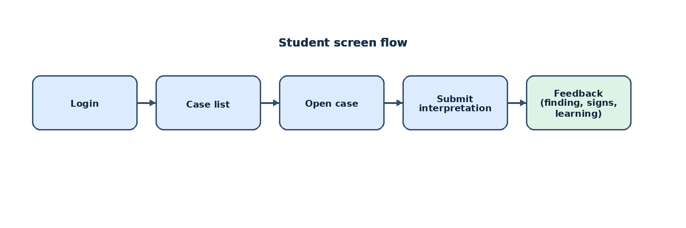
Figure 3.8: Educator workflow screen flow (login, review queue, review form).
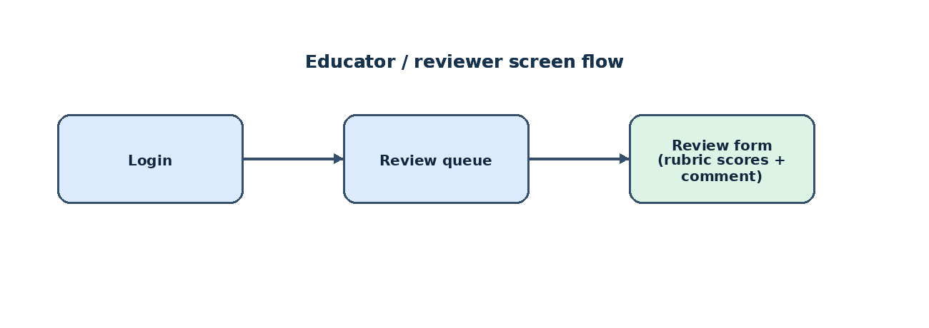

3.4 Implementation
The implementation phase turns the architecture into code. Figure 3.5 shows the component diagram; Figure 3.6 shows the deployment diagram. The backend is implemented in Python 3.11+ with FastAPI, SQLAlchemy 2, Pydantic 2 and PyJWT. The frontend is implemented in TypeScript with React 18, Vite, TanStack Query, react-hook-form and Zod. The Kaggle runtime is implemented as a small Flask app inside the notebook, wrapped by pyngrok and called through a single POST /generate endpoint.
Figure 3.5: Component diagram of the artefact.
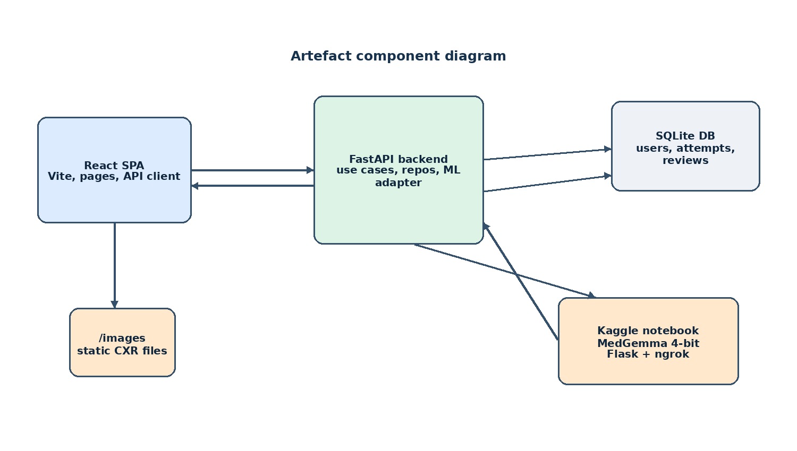
Figure 3.6: Deployment diagram.
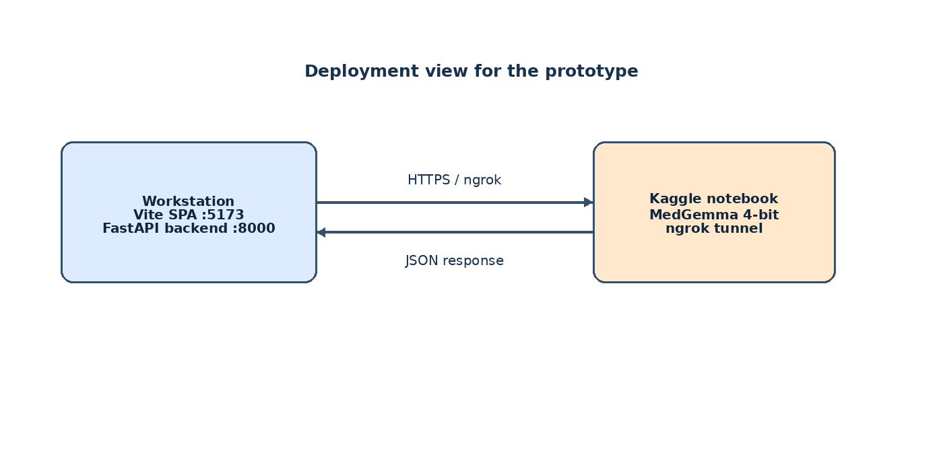
The implementation followed an iterative prototyping plan with short cycles (1-3 days each). Each cycle ended in a runnable artefact plus the unit and integration tests that cover the new behaviour. The implementation was tracked in a task list and reviewed with the project supervisor at the end of each cycle.

3.5 Testing
The testing strategy follows a layered model: unit tests at the domain and infrastructure level, integration tests at the API and data pipeline level, and system tests at the end-to-end level. The mapping of test layers to test scope and tools is summarised in Table 3.13. The full test plan and the test cases are delivered as part of the companion artefact document (Chapter 4); this methodology section summarises the layers, the tooling and the achieved test counts.
Layer | Scope | Tool | Run-time
Unit (domain) | Entities, value objects, ports | pytest | < 1 s
Unit (application) | Use cases, with fake ports | pytest | < 1 s
Unit (infrastructure) | Repos, parsers, auth, ML adapters, retrievers, eval harness | pytest | < 5 s
Unit (interfaces) | Routes, exception handlers, schemas | pytest + httpx.AsyncClient | < 5 s
Integration | End-to-end API with fake IMedGemmaClient and in-memory repos; auth roundtrip; attempt -> feedback; review queue | pytest + httpx.AsyncClient | < 10 s
Integration (data) | NIH loader, manifest builder, image download | pytest, real NIH subset | < 60 s
Golden | Prompt-builder and output-parser against golden JSON | pytest | < 1 s
System (manual) | Vite dev server, FastAPI, dry-run analyzer, real CXR case, manual submission of free text | manual smoke test | manual
Evaluation | Phase 1 metrics on the curated subset | scripts/run_eval.py | < 5 min (dry-run)
Table 3.13: Mapping of test layers to test scope and tools

3.5.1 Unit Testing
Unit tests cover the domain layer (entities, value objects, ports), the application layer (use cases with fake ports), the infrastructure layer (repos, parsers, auth, ML adapters, retrievers, eval harness) and the interfaces layer (routes, exception handlers, schemas). The unit tests are organised to mirror the source tree under backend/tests/. A single pytest invocation runs the full unit test suite in under five seconds and produces a coverage report for the domain and application layers.

3.5.2 Integration Testing
Integration tests focus on whether the set of modules function together without error. The auth roundtrip (register -> login -> me) is covered, as is the role guard (a student cannot POST a review, an unauthenticated request is rejected). The attempt -> feedback roundtrip is exercised end-to-end with a fake IMedGemmaClient that returns a fixed JSON payload; the test asserts that the response contains the expected feedback fields. The data-pipeline integration test downloads a small NIH subset, builds the manifest and asserts the per-finding counts.

3.5.3 System Testing
System testing verifies that the system as a whole meets the functional and non-functional requirements. The artefact is exercised end-to-end through a manual smoke test: the developer starts the FastAPI backend and the Vite dev server, opens the SPA, registers a student, opens a case, submits a free-text interpretation, and verifies that the structured feedback is returned. The Phase 1 evaluation harness (scripts/run_eval.py) is then run on the curated subset to produce a quantitative report (structure validity, finding recognition, per-finding breakdown, latency, token usage). The achieved test counts at the end of the implementation phase are summarised in Table 3.14.
Layer | Number of tests | Result
Domain unit tests | 85 | Pass
Application unit tests | 37 | Pass
Infrastructure unit tests | 92 | Pass
Interface unit tests | 21 | Pass
Integration tests | 15 | Pass
Golden tests | 7 | Pass
Total | 257 | Pass
Lint (ruff + mypy --strict) | n/a | Clean
Frontend lint (oxlint + tsc -b) | n/a | Clean
Table 3.14: Summary of automated test counts
Gantt chart of the project plan (Figure 3.9). The horizontal axis is the 15-week semester; the vertical axis is the eight phases defined in Section 3.1.2.5.
Figure 3.9: Gantt chart of the project plan.
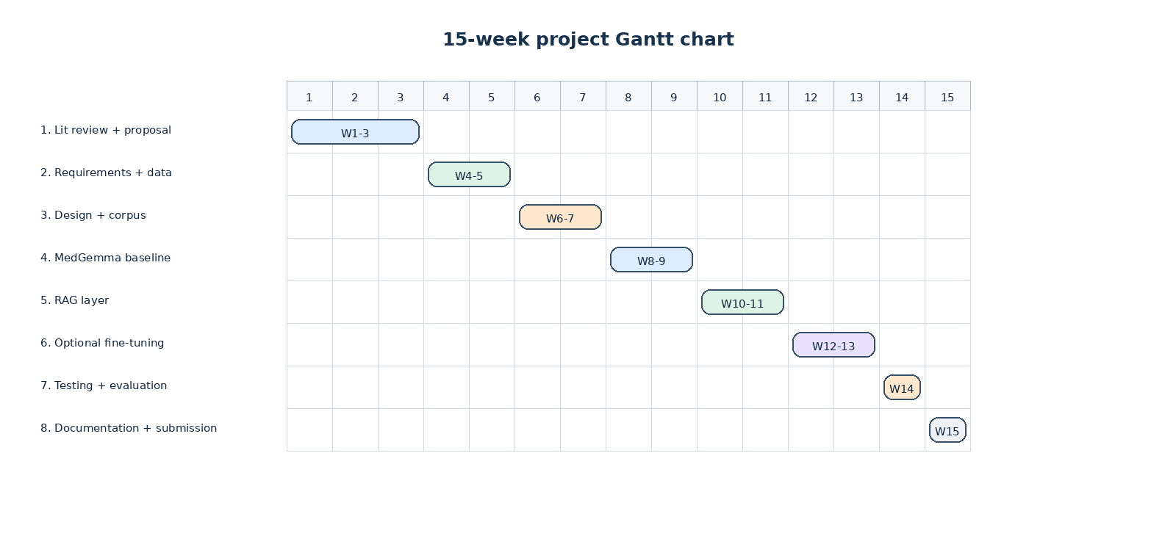

References
All in-text citations in this report follow the Harvard referencing style. The reference list is ordered alphabetically by the first author's surname.
Abo El-Enen, M., Saad, S. and Nazmy, T. (2025) 'A survey on retrieval-augmentation generation (RAG) models for healthcare applications', Neural Computing and Applications. Available at: https://doi.org/10.1007/s00521-025-11666-9 (Accessed: 9 June 2026).
Amugongo, L.M., Mascheroni, P., Brooks, S., Doering, S. and Seidel, J. (2025) 'Retrieval augmented generation for large language models in healthcare: A systematic review', PLOS Digital Health, 4(6), e0000877. Available at: https://doi.org/10.1371/journal.pdig.0000877 (Accessed: 27 May 2026).
Chen, Z. et al. (2024) 'A vision-language foundation model to enhance efficiency of chest X-ray interpretation', arXiv:2401.12208. Available at: https://doi.org/10.48550/arXiv.2401.12208 (Accessed: 18 June 2026).
Collaco, B.G. et al. (2026) 'Integrating fine-tuning and retrieval-augmented generation for healthcare AI systems: A scoping review', Bioengineering, 13(2), 225. Available at: https://doi.org/10.3390/bioengineering13020225 (Accessed: 2 June 2026).
European Parliament and Council of the European Union (2016) 'Regulation (EU) 2016/679: General Data Protection Regulation'. Available at: https://eur-lex.europa.eu/eli/reg/2016/679/oj (Accessed: 25 May 2026).
Gosai, A. et al. (2025) 'Beyond diagnosis: Evaluating multimodal LLMs for pathology localization in chest radiographs', arXiv:2509.18015. Available at: https://arxiv.org/abs/2509.18015 (Accessed: 13 June 2026).
Google Developers (2026) MedGemma | Health AI Developer Foundations. Available at: https://developers.google.com/health-ai-developer-foundations/medgemma (Accessed: 4 June 2026).
Johnson, A.E.W. et al. (2019) 'MIMIC-CXR, a de-identified publicly available database of chest radiographs with free-text reports', Scientific Data, 6, 317. Available at: https://doi.org/10.1038/s41597-019-0322-0 (Accessed: 5 June 2026).
Karunaratne, D. (2023) 'The growing problem of radiologist shortage in Sri Lanka', Korean Journal of Radiology, 24(10), pp. 941-943. doi: 10.3348/kjr.2023.0791. Available at: https://pmc.ncbi.nlm.nih.gov/articles/PMC10550747/ (Accessed: 29 May 2026).
Lee, S., Youn, J., Kim, H., Kim, M. and Yoon, S.H. (2025) 'CXR-LLaVA: a multimodal large language model for interpreting chest X-ray images', European Radiology, 35(7), pp. 4374-4386. Available at: https://doi.org/10.1007/s00330-024-11339-6 (Accessed: 20 June 2026).
Li, C. et al. (2023) 'LLaVA-Med: Training a large language-and-vision assistant for biomedicine in one day', Advances in Neural Information Processing Systems 36. Available at: https://proceedings.neurips.cc/paper_files/paper/2023/hash/5abcdf8ecdcacba028c6662789194572-Abstract-Datasets_and_Benchmarks.html (Accessed: 31 May 2026).
Lin, Q. et al. (2025) 'Toward clinically explainable AI for medical diagnosis: A foundation model with human-compatible reasoning via reinforcement learning', arXiv:2509.03906. Available at: https://arxiv.org/abs/2509.03906 (Accessed: 16 June 2026).
Liu, S., McCoy, A.B. and Wright, A. (2025) 'Improving large language model applications in biomedicine with retrieval-augmented generation: A systematic review, meta-analysis, and clinical development guidelines', Journal of the American Medical Informatics Association, 32(4), pp. 605-615. Available at: https://doi.org/10.1093/jamia/ocaf008 (Accessed: 7 June 2026).
Lou, J., Yang, Y., Yu, Z., Fu, Z., Han, W., Huang, Q. and Yu, J. (2025) 'CXRAgent: Director-orchestrated multi-stage reasoning for chest X-ray interpretation', arXiv:2510.21324. Available at: https://arxiv.org/abs/2510.21324 (Accessed: 26 May 2026).
Mugambiwa, T. and Ndlovu, B. (2026) 'Multi-agent retrieval augmented generation for clinical decision support: A systematic review and integrative conceptual framework', Journal of Applied Informatics and Computing, 10(1), pp. 171-183. Available at: https://www.semanticscholar.org/paper/Multi-Agent-Retrieval-Augmented-Generation-for-A-Mugambiwa-Ndlovu/eeab620e9d8c8d0c4215b2d39bcced9fc4d9440c (Accessed: 11 June 2026).
National Institute of Standards and Technology (2023) 'Artificial Intelligence Risk Management Framework (AI RMF 1.0)'. Available at: https://doi.org/10.6028/NIST.AI.100-1 (Accessed: 3 June 2026).
OWASP Foundation (2021) 'OWASP Top 10: The ten most critical web application security risks'. Available at: https://owasp.org/Top10/2021/ (Accessed: 19 June 2026).
OWASP Foundation (2025) 'OWASP Top 10 for Large Language Model Applications'. Available at: https://owasp.org/www-project-top-10-for-large-language-model-applications/ (Accessed: 28 May 2026).
Pal, A. et al. (2025) 'ReXVQA: A large-scale visual question answering benchmark for generalist chest X-ray understanding', arXiv:2506.04353. Available at: https://arxiv.org/abs/2506.04353 (Accessed: 14 June 2026).
Pambudi, S. and Menolascina, F. (2025) 'Bridging clinical narratives and ACR Appropriateness Guidelines: A multi-agent RAG system for medical imaging decisions', arXiv:2510.04969. Available at: https://arxiv.org/abs/2510.04969 (Accessed: 1 June 2026).
Papageorgiou, P.S. et al. (2025) 'The role of large language models in improving diagnostic-related groups assignment and clinical decision support in healthcare systems: An example from radiology and nuclear medicine', Applied Sciences, 15(16), 9005. Available at: https://doi.org/10.3390/app15169005 (Accessed: 10 June 2026).
Parliament of Sri Lanka (2022) 'Personal Data Protection Act, No. 9 of 2022'. Available at: https://parliament.lk/uploads/acts/gbills/english/6242.pdf (Accessed: 6 June 2026).
Sellergren, A. et al. (2025) 'MedGemma Technical Report', arXiv:2507.05201. Available at: https://arxiv.org/abs/2507.05201 (Accessed: 17 June 2026).
Wang, X. et al. (2017) 'ChestX-ray8: Hospital-scale chest X-ray database and benchmarks on weakly-supervised classification and localization of common thorax diseases', Proceedings of the IEEE Conference on Computer Vision and Pattern Recognition (CVPR), pp. 2097-2106. Available at: https://doi.org/10.1109/CVPR.2017.369 (Accessed: 30 May 2026).
World Health Organization (2021) 'Ethics and governance of artificial intelligence for health: WHO guidance'. Geneva: World Health Organization. Available at: https://www.who.int/publications/i/item/9789240029200 (Accessed: 15 June 2026).
Zambrano Chaves, J.M. et al. (2025) 'A clinically accessible small multimodal radiology model and evaluation metric for chest X-ray findings', Nature Communications, 16, 3108. Available at: https://doi.org/10.1038/s41467-025-58344-x (Accessed: 4 June 2026).

